**IHO Cover Page here.**

S-121 GML encoding Documentation

Contents

SNAG LIST 3

1. Introduction 5

2. Application Schema Details 6

3. Geo 7

AbstractGeographicFeatureType 7

AbstractLimitType 9

AbstractLocationType 9

AbstractZoneType 10

AdditionalSpatialInformation 10

FeatureName 11

LocationReference 11

CategoryOfLocation 12

JurisdictionDomain 13

PointType 13

ReleasabilityType 14

Note 14

Note 14

Note 15

4. LADM 16

AbstractRRR 16

Basic Administrative Unit 17

Governance 18

Party 19

PartyMembership 21

Responsibility 21

Restriction 21

Right 22

CategoryOfResponsibility 22

CategoryOfRestriction 22

CategoryOfRight 23

PartyGroupType 24

Text 24

5. Source Documentation 25

6. GML Encoding Notes 25

# SNAG LIST

Snag list for the GML Annex documentation.

**For Covering Paper**

* MRN – put in but remains optional. FOID is also included in the standard S-100 Profile DSID element so we can allude to that and make sure it is a viable alternative.
* Aggregations and Relationships. The way in which hierarchies can be built
* Many to many BAU relationships
* GML version 3.2.1 needs to be extracted from the include files.
* Geometry element type is gml: (namespace) for compatibility with OGR tools
* Referenced vs Absolute geometry – needs validation testing.
* Is there anything we need to say about metadata? We certainly need to clarify the position wrt metadata in the S-100 profile (the dataset metadata) and what is currently defined in the GML schema and feature catalogue.
* Some ideas for validation tests that might be part of the main S-121 document (or DCEG?)
* Some notes on filling in DSID and DSSI elements?
* Should startLifespan and endLifespan be wrapped in “FixedDateRange” – this is used in other product specifications and is possible a more coherent way of versioning by date – NIPWG use it a lot in other product specifications.
* Multi-lingual issues
  + locationText – need to investigate – this could be a better solution for multilingual names.
  + Locale is in the current S-121 model – this isn’t the normal way of achieving multi-lingual content in S-100 but we should try to make a compatible model..

**For Schema document**

* MRN – suitable notes. For the PT, need to understand MRN is optional and actions underway at IHO to resolve issues with it.
* locationText? Could replace featureName
* label? Used? In feature Catalogue.
* Check LADM against model – did we add GovernanceDescription?

**Other.**

* Items to add to feature Catalogue.
  + locationReference
  + textLat
  + textLon
  + categoryOfLocation
  + mrn
  + date**** in LADM features.
* check spelling and order.

**Relationships**

* Multiple BAU->Geospatial relns
* Intermediate Party / Part member.

# Introduction

This document contains details of the IHO S-121 GML Encoding format. In order to reduce complexity and provide a concise guide to the structure of the GML Encoding a subset of all elements within the encoding are provided here alongside any necessary detail and background.

There is a large degree of duplication in the types within the S-121 GML Application Schema so duplicated types are noted, but the repeated detail left out of this document. The schema itself contains normative definitions for all types and references to the S-100 base schemas.

# Application Schema Details

There are three main packages contained within the S-121 GML Schema. These are documented individually within this document.

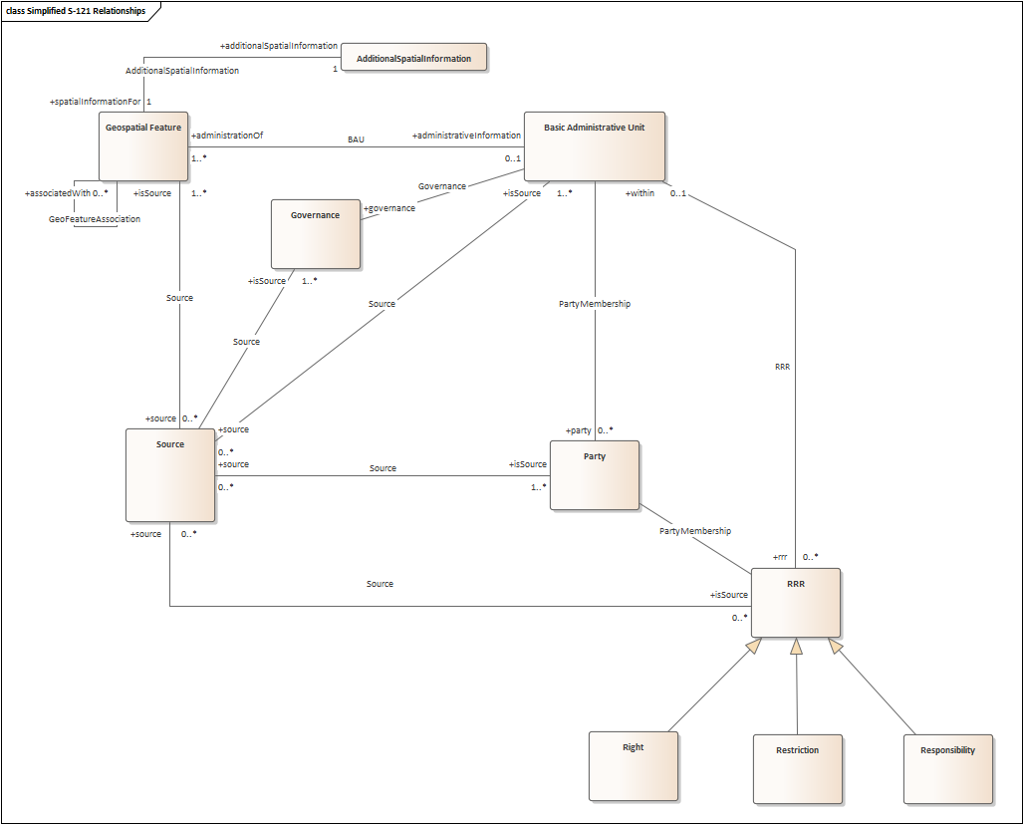

Figure : Simplified View of packages and their relationships within the schema (v1)

Package descriptions

Feature Aggregation into datasets

* Dataset order
* Relationships are between I-I and F-I
* How features are grouped. Dataset collection item

# Geo

Package in package 'S-121'



1. GeospatialFeatures

## AbstractGeographicFeatureType

Class «FeatureType» in package 'S-121'

AbstractGeographicFeatureType is the base type for all the geospatial features. From this base type the point, limit and zone types are derived

| ATTRIBUTES |
| --- |
| mrn : Text Public  Multiplicity: ( [0..1], Allow duplicates: 0, Is ordered: False )  MRN has been added to the GML Schema and Feature catalogue. This requires harmonisation with other efforts within the IHO geospatial registry in line with its inclusion within the S-100 framework. MRN in the context of S-121 is "optional" - the option of using the S-100 Profile's FeatureObjectIdentifier element ("foid") is an acceptable alternative as a persistent unique identifier for individual features.  [ Stereotype is «SimpleAttribute». Is static True. Containment is Not Specified. ] |
| label : Text Public  Multiplicity: ( [0..1], Allow duplicates: 0, Is ordered: False )  [ Stereotype is «SimpleAttribute». Is static True. Containment is Not Specified. ] |
| collectionName : Text Public  Multiplicity: ( [0..1], Allow duplicates: 0, Is ordered: False )  A textual label representing a neutral "Collection" label for the feature. This allows multiple groupings (either by state, function or other criteria) to exist within a single dataset.  [ Stereotype is «SimpleAttribute». Is static True. Containment is Not Specified. ] |
| featureName : FeatureName Public  Multiplicity: ( [0..*], Allow duplicates: 0, Is ordered: False )  [ Stereotype is «ComplexAttribute». Is static True. Containment is Not Specified. ] |
| context : Text Public  Multiplicity: ( [0..1], Allow duplicates: 0, Is ordered: False )  [ Stereotype is «SimpleAttribute». Is static True. Containment is Not Specified. ] |
| startLifespan : date Public  Multiplicity: ( [0..1], Allow duplicates: 0, Is ordered: False )  [ Stereotype is «SimpleAttribute». Is static True. Containment is Not Specified. ] |
| endLifespan : date Public  Multiplicity: ( [0..1], Allow duplicates: 0, Is ordered: False )  [ Stereotype is «SimpleAttribute». Is static True. Containment is Not Specified. ] |
| locationReference : LocationReference Public  Multiplicity: ( [0..1], Allow duplicates: 0, Is ordered: False )  An inline locationReference attribute - this allows inclusion of a single textual representation of a location if required. If multiple textual representations are required then they should be specified using an association with the AdditionalSpatialInformation information type.  [ Stereotype is «ComplexAttribute». Is static True. Containment is Not Specified. ] |
| releasabilityType : ReleasabilityType Public  Multiplicity: ( [0..1], Allow duplicates: 0, Is ordered: False )  [ Stereotype is «SimpleAttribute». Is static True. Containment is Not Specified. ] |

| ASSOCIATIONS | |
| --- | --- |
| Association (direction: Unspecified) AdditionalInformation | |
| Source: Public identifies (Class) AbstractGeographicFeatureType «FeatureType»  Cardinality: [1..*] | Target: Public refersTo (Class) AdditionalSpatialInformation «InformationType»  Cardinality: [0..*] |
| Association (direction: Unspecified) Geo Aggregation | |
| Source: Public composedOf (Class) AbstractGeographicFeatureType «FeatureType» | Target: Public consistsOf (Class) AbstractGeographicFeatureType «FeatureType»  Cardinality: [0..*] |
| Association (direction: Unspecified) BAU | |
| Source: Public administrationOf (Class) AbstractGeographicFeatureType «FeatureType»  Cardinality: [0..*] | Target: Public administrativeInformation (Class) Basic Administrative Unit «InformationType»  Cardinality: [0..*] |
| Association (direction: Unspecified) Geo Aggregation | |
| Source: Public composedOf (Class) AbstractGeographicFeatureType «FeatureType» | Target: Public consistsOf (Class) AbstractGeographicFeatureType «FeatureType»  Cardinality: [0..*] |

## AbstractLimitType

Class «FeatureType» in package 'S-121'

| OUTGOING STRUCTURAL RELATIONSHIPS |
| --- |
| Realization from «FeatureType» AbstractLimitType to «FeatureType» AbstractGeographicFeatureType  [ Direction is 'Source -> Destination'. ] |

| ATTRIBUTES |
| --- |
| interpolationType : Text Public  Multiplicity: ( [0..1], Allow duplicates: 0, Is ordered: False )  [ Stereotype is «SimpleAttribute». Is static True. Containment is Not Specified. ] |

## AbstractLocationType

Class «FeatureType» in package 'S-121'

AbstractLocationType

Version 1.0 Phase 1.0 Proposed

kusal created on 28/01/2020. Last modified 06/02/2020

| OUTGOING STRUCTURAL RELATIONSHIPS |
| --- |
| Realization from «FeatureType» AbstractLocationType to «FeatureType» AbstractGeographicFeatureType  [ Direction is 'Source -> Destination'. ] |

| ATTRIBUTES |
| --- |
| interpolationType : Text Public  Multiplicity: ( [0..1], Allow duplicates: 0, Is ordered: False )  [ Stereotype is «SimpleAttribute». Is static True. Containment is Not Specified. ] |
| pointType : PointType Public  Multiplicity: ( [0..1], Allow duplicates: 0, Is ordered: False )  [ Stereotype is «SimpleAttribute». Is static True. Containment is Not Specified. ] |

## AbstractZoneType

Class «FeatureType» in package 'S-121'

AbstractZoneType

Version 1.0 Phase 1.0 Proposed

kusal created on 28/01/2020. Last modified 06/02/2020

| OUTGOING STRUCTURAL RELATIONSHIPS |
| --- |
| Realization from «FeatureType» AbstractZoneType to «FeatureType» AbstractGeographicFeatureType  [ Direction is 'Source -> Destination'. ] |

| ATTRIBUTES |
| --- |
| jurisdictionDomain : JurisdictionDomain Public  Multiplicity: ( [0..1], Allow duplicates: 0, Is ordered: False )  [ Stereotype is «SimpleAttribute». Is static True. Containment is Not Specified. ] |

## AdditionalSpatialInformation

Class «InformationType» in package 'S-121'

An information type holding a number of locationReference entries. This can store multiple textual representations of a position and reference system and can be shared between multiple geospatial features as well.

AdditionalSpatialInformation

Version 1.0 Phase 1.0 Proposed

kusal created on 28/01/2020. Last modified 19/06/2020

| ATTRIBUTES |
| --- |
| locationReference : LocationReference Public  Multiplicity: ( [1..*], Allow duplicates: 0, Is ordered: False )  [ Stereotype is «ComplexAttribute». Is static True. Containment is Not Specified. ] |

| ASSOCIATIONS | |
| --- | --- |
| Association (direction: Unspecified) AdditionalInformation | |
| Source: Public identifies (Class) AbstractGeographicFeatureType «FeatureType»  Cardinality: [1..*] | Target: Public refersTo (Class) AdditionalSpatialInformation «InformationType»  Cardinality: [0..*] |

## FeatureName

Class «ComplexAttributeType» in package 'S-121'

A copy of the IHO registry entry for Naming of features. This complex attribute allows for a number of names to be stored alongside a language identifier. The attribute "displayName" is included for compatibility with other featureName uses and could possibly be removed in the future.

| ATTRIBUTES |
| --- |
| displayName : boolean Private  [ Is static True. Containment is Not Specified. ] |
| Language : Text Private  [ Is static True. Containment is Not Specified. ] |
| Name : Text Private  [ Is static True. Containment is Not Specified. ] |

## LocationReference

DataType «ComplexAttributeType» in package 'S-121'

LocationReference

Version 1.0 Phase 1.0 Proposed

kusal created on 19/06/2020. Last modified 19/06/2020

| ATTRIBUTES |
| --- |
| categoryOfLocation : CategoryOfLocation Public  Multiplicity: ( [0..1], Allow duplicates: 0, Is ordered: False )  [ Stereotype is «SimpleAttribute». Is static True. Containment is Not Specified. ] |
| locationByText : Text Public  Multiplicity: ( [0..1], Allow duplicates: 0, Is ordered: False )  If a location is not described in latitude/longitude form then a textual description of a position (or number of positions) can be described in locationByText  [ Stereotype is «SimpleAttribute». Is static True. Containment is Not Specified. ] |
| textLat : Text Public  Multiplicity: ( [0..1], Allow duplicates: 0, Is ordered: False )  Textual representation of a latitude position.  [ Stereotype is «SimpleAttribute». Is static True. Containment is Not Specified. ] |
| textLon : Text Public  Multiplicity: ( [0..1], Allow duplicates: 0, Is ordered: False )  Textual representation of a longitude.  [ Stereotype is «SimpleAttribute». Is static True. Containment is Not Specified. ] |
| referenceSystem : Text Public  A textual description or reference to the reference system for a textually defined position. this could be a formal datum or description of a datum (historical)  [ Stereotype is «SimpleAttribute». Is static True. Containment is Not Specified. ] |

## CategoryOfLocation

Enumeration in package 'S-121'

| ATTRIBUTES |
| --- |
| AdditionalSpatialInformation : Public  [ Stereotype is «enum». Is static True. Containment is Not Specified. ] |
| OriginalLocation : Public  [ Stereotype is «enum». Is static True. Containment is Not Specified. ] |
| OfficialLocation : Public  [ Stereotype is «enum». Is static True. Containment is Not Specified. ] |
| CommonLocation : Public  [ Stereotype is «enum». Is static True. Containment is Not Specified. ] |
| GlobalLocation : Public  [ Stereotype is «enum». Is static True. Containment is Not Specified. ] |
| WGS84Location : Public  [ Stereotype is «enum». Is static True. Containment is Not Specified. ] |

## JurisdictionDomain

Enumeration in package 'S-121'

JurisdictionDomain

Version 1.0 Phase 1.0 Proposed

kusal created on 05/02/2020. Last modified 13/02/2020

| ATTRIBUTES |
| --- |
| Airspace : Public  [ Stereotype is «enum». Is static True. Containment is Not Specified. ] |
| Land Surface : Public  [ Stereotype is «enum». Is static True. Containment is Not Specified. ] |
| Water Surface : Public  [ Stereotype is «enum». Is static True. Containment is Not Specified. ] |
| Water Column : Public  [ Stereotype is «enum». Is static True. Containment is Not Specified. ] |
| Seabed Surface : Public  [ Stereotype is «enum». Is static True. Containment is Not Specified. ] |
| Subsoil : Public  [ Stereotype is «enum». Is static True. Containment is Not Specified. ] |

## PointType

Enumeration in package 'S-121'

PointType

Version 1.0 Phase 1.0 Proposed

kusal created on 05/02/2020. Last modified 13/02/2020

| ATTRIBUTES |
| --- |
| defined : Public  [ Stereotype is «enum». Is static True. Containment is Not Specified. ] |
| computed : Public  [ Stereotype is «enum». Is static True. Containment is Not Specified. ] |

## ReleasabilityType

Enumeration in package 'S-121'

ReleasabilityType

Version 1.0 Phase 1.0 Proposed

kusal created on 05/02/2020. Last modified 13/02/2020

| ATTRIBUTES |
| --- |
| Official : Public  [ Stereotype is «enum». Is static True. Containment is Not Specified. ] |
| Internal : Public  [ Stereotype is «enum». Is static True. Containment is Not Specified. ] |
| Controlled : Public  [ Stereotype is «enum». Is static True. Containment is Not Specified. ] |

## Note

Note in package 'Geo'

All Point Features Derive from this feature types (omitted here for clarity)

* Baseline Point
* Limit Point
* Boundary Point
* Contributing Point

## Note

Note in package 'Geo'

All Line features (baselines, outer limits) derive from this feature type (omitted here for clarity)

* Baseline
* NormalBaseline
* StraightBaseline
* ArchipelagicBaseline
* LowTideElevationBaseline
* MouthOfRiversBaseline
* BayBaseline
* PortBaseline
* ReefBaseline
* Boundary
* InternationalBoundary
* Limit
* OuterLimitOfTheTerritorialSea
* OuterLimitOfTheContiguousZone
* OuterLimitOfTheExclusiveEconomicZone
* OuterLimitOfTheContinentalShelf
* OuterLimitOfTheRoadstead
* ConstructionLine

## Note

Note in package 'Geo'

All Area features (Zones) derive from this feature type (omitted here for clarity)

* Zone
* TerritorialSea
* ContiguousZone
* ExclusiveEconomicZone
* ContinentalShelf
* Roadstead
* InternalWaters
* TheArea
* HighSeas
* ArchipelagicWaters

Strait

# LADM



1. LADM Features

## AbstractRRR

Class «InformationType» in package 'S-121'

AbstractRRR

Version 1.0 Phase 1.0 Proposed

kusal created on 05/02/2020. Last modified 05/02/2020

| INCOMING STRUCTURAL RELATIONSHIPS |
| --- |
| Generalization from «InformationType» Restriction to «InformationType» AbstractRRR  [ Direction is 'Source -> Destination'. ] |
| Generalization from «InformationType» Right to «InformationType» AbstractRRR  [ Direction is 'Source -> Destination'. ] |
| Generalization from «InformationType» Responsibility to «InformationType» AbstractRRR  [ Direction is 'Source -> Destination'. ] |

| ATTRIBUTES |
| --- |
| rrrDescription : Text Public  Multiplicity: ( [0..1], Allow duplicates: 0, Is ordered: False )  [ Stereotype is «SimpleAttribute». Is static True. Containment is Not Specified. ] |
| rrrTimespec : Date Public  Multiplicity: ( [0..1], Allow duplicates: 0, Is ordered: False )  [ Stereotype is «SimpleAttribute». Is static True. Containment is Not Specified. ] |
| rrrShare : Double Public  Multiplicity: ( [0..1], Allow duplicates: 0, Is ordered: False )  [ Stereotype is «SimpleAttribute». Is static True. Containment is Not Specified. ] |

| ASSOCIATIONS | |
| --- | --- |
| AssociationClass (direction: Unspecified) Membership | |
| Source: Public partyMember (Class) Party «InformationType»  Cardinality: [0..*] | Target: Public administrationOf (Class) AbstractRRR «InformationType»  Cardinality: [0..*] |
| Association (direction: Unspecified) RRR | |
| Source: Public administrationBy (Class) Basic Administrative Unit «InformationType»  Cardinality: [0..1] | Target: Public administrationOf (Class) AbstractRRR «InformationType»  Cardinality: [0..*] |

## Basic Administrative Unit

Class «InformationType» in package 'S-121'

Basic Administrative Unit

Version 1.0 Phase 1.0 Proposed

kusal created on 28/01/2020. Last modified 05/02/2020

| ATTRIBUTES |
| --- |
| basicAdministrativeUnitName : Text Public  [ Stereotype is «SimpleAttribute». Is static True. Containment is Not Specified. ] |
| basicAdministrativeUnitType : Text Public  Multiplicity: ( [0..1], Allow duplicates: 0, Is ordered: False )  [ Stereotype is «SimpleAttribute». Is static True. Containment is Not Specified. ] |
| basicAdministrativeUnitContext : Text Public  Multiplicity: ( [0..1], Allow duplicates: 0, Is ordered: False )  [ Stereotype is «SimpleAttribute». Is static True. Containment is Not Specified. ] |

| ASSOCIATIONS | |
| --- | --- |
| AssociationClass (direction: Unspecified) | |
| Source: Public (Class) Basic Administrative Unit «InformationType» | Target: Public (Class) Basic Administrative Unit «InformationType» |
| Association (direction: Unspecified) RRR | |
| Source: Public administrationBy (Class) Basic Administrative Unit «InformationType»  Cardinality: [0..1] | Target: Public administrationOf (Class) AbstractRRR «InformationType»  Cardinality: [0..*] |
| AssociationClass (direction: Unspecified) | |
| Source: Public (Class) Basic Administrative Unit «InformationType» | Target: Public (Class) Basic Administrative Unit «InformationType» |
| Association (direction: Unspecified) BAU | |
| Source: Public administrationOf (Class) AbstractGeographicFeatureType «FeatureType»  Cardinality: [0..*] | Target: Public administrativeInformation (Class) Basic Administrative Unit «InformationType»  Cardinality: [0..*] |
| Association (direction: Unspecified) Governance | |
| Source: Public governanceOf (AssociationClass) Governance «Information Type»  Cardinality: [0..*] | Target: Public governanceFor (Class) Basic Administrative Unit «InformationType»  Cardinality: [0..*] |
| Association (direction: Unspecified) PartyMembership | |
| Source: Public party (Class) Party «InformationType»  Cardinality: [0..*] | Target: Public administrationBy (Class) Basic Administrative Unit «InformationType»  Cardinality: [0..*] |

## Governance

AssociationClass «Information Type» in package 'S-121'

Governance

Version 1.0 Phase 1.0 Proposed

kusal created on 22/02/2020. Last modified 23/02/2020

| ATTRIBUTES |
| --- |
| label : Text Public  [ Stereotype is «SimpleAttribute». Is static True. Containment is Not Specified. ] |
| referenceNumber : Text Public  [ Stereotype is «SimpleAttribute». Is static True. Containment is Not Specified. ] |
| governanceTitle : Text Public  [ Stereotype is «SimpleAttribute». Is static True. Containment is Not Specified. ] |
| governanceDescription : Text Public  [ Stereotype is «SimpleAttribute». Is static True. Containment is Not Specified. ] |
| releasabilityType : ReleasabilityType Private  [ Stereotype is «SimpleAttribute». Is static True. Containment is Not Specified. ] |
| dateConsidered : date Public  [ Stereotype is «SimpleAttribute». Is static True. Containment is Not Specified. ] |
| dateApproved : date Public  [ Stereotype is «SimpleAttribute». Is static True. Containment is Not Specified. ] |
| dateIntroduced : date Public  [ Stereotype is «SimpleAttribute». Is static True. Containment is Not Specified. ] |
| featureName : FeatureName Public  [ Stereotype is «ComplexAttribute». Is static True. Containment is Not Specified. ] |

| ASSOCIATIONS | |
| --- | --- |
| Association (direction: Unspecified) Governance | |
| Source: Public governanceOf (AssociationClass) Governance «Information Type»  Cardinality: [0..*] | Target: Public governanceFor (Class) Basic Administrative Unit «InformationType»  Cardinality: [0..*] |

## Party

Class «InformationType» in package 'S-121'

Party

Version 1.0 Phase 1.0 Proposed

kusal created on 28/01/2020. Last modified 05/02/2020

| ATTRIBUTES |
| --- |
| partyName : int Private  [ Is static True. Containment is Not Specified. ] |
| partyRole : int Private  Multiplicity: ( [0..1], Allow duplicates: 0, Is ordered: False )  [ Is static True. Containment is Not Specified. ] |
| categoryOfParty : int Private  Multiplicity: ( [0..1], Allow duplicates: 0, Is ordered: False )  [ Is static True. Containment is Not Specified. ] |
| partyGroupType : PartyGroupType Private  [ Is static True. Containment is Not Specified. ] |
| partyGroup : boolean Private  [ Is static True. Containment is Not Specified. ] |

| ASSOCIATIONS | |
| --- | --- |
| Association (direction: Unspecified) | |
| Source: Public (Class) Party «InformationType» | Target: Public (AssociationClass) PartyMember «InformationType» |
| AssociationClass (direction: Unspecified) Membership | |
| Source: Public partyMember (Class) Party «InformationType»  Cardinality: [0..*] | Target: Public administrationOf (Class) AbstractRRR «InformationType»  Cardinality: [0..*] |
| AssociationClass (direction: Unspecified) | |
| Source: Public group (Class) Party «InformationType»  Cardinality: [0..*] | Target: Public member (Class) Party «InformationType»  Cardinality: [1..] |
| Association (direction: Unspecified) PartyMembership | |
| Source: Public party (Class) Party «InformationType»  Cardinality: [0..*] | Target: Public administrationBy (Class) Basic Administrative Unit «InformationType»  Cardinality: [0..*] |
| AssociationClass (direction: Unspecified) | |
| Source: Public group (Class) Party «InformationType»  Cardinality: [0..*] | Target: Public member (Class) Party «InformationType»  Cardinality: [1..] |
| Association (direction: Unspecified) | |
| Source: Public (AssociationClass) PartyMember «InformationType» | Target: Public (Class) Party «InformationType» |

## PartyMembership

AssociationClass «InformationType» in package 'S-121'

PartyMembership

Version 1.0 Phase 1.0 Proposed

kusal created on 23/02/2020. Last modified 23/02/2020

| ATTRIBUTES |
| --- |
| partyMembership : Double Public  [ Stereotype is «SimpleAttribute». Is static True. Containment is Not Specified. ] |

## Responsibility

Class «InformationType» in package 'S-121'

Responsibility

Version 1.0 Phase 1.0 Proposed

kusal created on 28/01/2020. Last modified 05/02/2020

| OUTGOING STRUCTURAL RELATIONSHIPS |
| --- |
| Generalization from «InformationType» Responsibility to «InformationType» AbstractRRR  [ Direction is 'Source -> Destination'. ] |

| ATTRIBUTES |
| --- |
| categoryOfResponsibility : CategoryOfResponsibility Public  Multiplicity: ( [0..1], Allow duplicates: 0, Is ordered: False )  [ Stereotype is «SimpleAttribute». Is static True. Containment is Not Specified. ] |

## Restriction

Class «InformationType» in package 'S-121'

Restriction

Version 1.0 Phase 1.0 Proposed

kusal created on 28/01/2020. Last modified 05/02/2020

| OUTGOING STRUCTURAL RELATIONSHIPS |
| --- |
| Generalization from «InformationType» Restriction to «InformationType» AbstractRRR  [ Direction is 'Source -> Destination'. ] |

| ATTRIBUTES |
| --- |
| categoryOfRestriction : CategoryOfRestriction Public  Multiplicity: ( [0..1], Allow duplicates: 0, Is ordered: False )  [ Stereotype is «SimpleAttribute». Is static True. Containment is Not Specified. ] |

## Right

Class «InformationType» in package 'S-121'

Right

Version 1.0 Phase 1.0 Proposed

kusal created on 28/01/2020. Last modified 05/02/2020

| OUTGOING STRUCTURAL RELATIONSHIPS |
| --- |
| Generalization from «InformationType» Right to «InformationType» AbstractRRR  [ Direction is 'Source -> Destination'. ] |

| ATTRIBUTES |
| --- |
| categoryOfRight : CategoryOfRight Public  Multiplicity: ( [0..1], Allow duplicates: 0, Is ordered: False )  [ Stereotype is «SimpleAttribute». Is static True. Containment is Not Specified. ] |

## CategoryOfResponsibility

Enumeration in package 'S-121'

CategoryOfResponsibility

Version 1.0 Phase 1.0 Proposed

kusal created on 06/02/2020. Last modified 13/02/2020

| ATTRIBUTES |
| --- |
| Maintenance Responsibility : Public  [ Stereotype is «enum». Is static True. Containment is Not Specified. ] |

## CategoryOfRestriction

Enumeration in package 'S-121'

CategoryOfRestriction

Version 1.0 Phase 1.0 Proposed

kusal created on 06/02/2020. Last modified 13/02/2020

| ATTRIBUTES |
| --- |
| Access Restriction : Public  [ Stereotype is «enum». Is static True. Containment is Not Specified. ] |
| Jurisdiction Restriction : Public  [ Stereotype is «enum». Is static True. Containment is Not Specified. ] |
| Passage Restriction : Public  [ Stereotype is «enum». Is static True. Containment is Not Specified. ] |
| Resource Restriction : Public  [ Stereotype is «enum». Is static True. Containment is Not Specified. ] |
| Time Based Restriction : Public  [ Stereotype is «enum». Is static True. Containment is Not Specified. ] |
| Use Restriction : Public  [ Stereotype is «enum». Is static True. Containment is Not Specified. ] |

## CategoryOfRight

Enumeration in package 'S-121'

CategoryOfRight

Version 1.0 Phase 1.0 Proposed

kusal created on 06/02/2020. Last modified 13/02/2020

| ATTRIBUTES |
| --- |
| Sovereignty : Public  [ Stereotype is «enum». Is static True. Containment is Not Specified. ] |
| Soveriegn Right : Public  [ Stereotype is «enum». Is static True. Containment is Not Specified. ] |
| Access Right : Public  [ Stereotype is «enum». Is static True. Containment is Not Specified. ] |
| Easement Right : Public  [ Stereotype is «enum». Is static True. Containment is Not Specified. ] |
| Harvest Right : Public  [ Stereotype is «enum». Is static True. Containment is Not Specified. ] |
| Contiguous Right : Public  [ Stereotype is «enum». Is static True. Containment is Not Specified. ] |

## PartyGroupType

Enumeration in package 'S-121'

PartyGroupType

Version 1.0 Phase 1.0 Proposed

kusal created on 19/02/2020. Last modified 19/02/2020

| ATTRIBUTES |
| --- |
| Agreement : Public  [ Stereotype is «enum». Is static True. Containment is Not Specified. ] |
| Association : Public  [ Stereotype is «enum». Is static True. Containment is Not Specified. ] |

## Text

Text in package 'S-121'

Text

Version 8.0 Phase 1.0 Proposed

kusal created on 13/02/2020. Last modified 12/06/2020

Extends

# Source Documentation

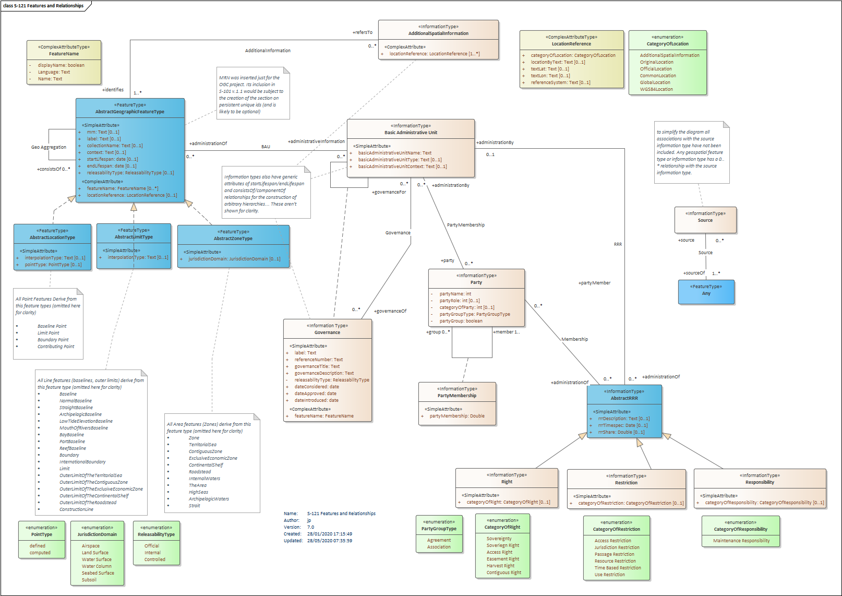

TBD – mirrored from GML Schema and Feature Catalogue.

# GML Encoding Notes

This section details the implementation of the S-100 GML Profile used within the S-121 GML Application Schema and notes areas where this may differ from other GML formats in the S-100 ecosystem.

JP_Notes (also from ER)

1. Use of MRN
2. Relationships
3. DCEG guidance
4. Use of GML 3.2.1
5. Geometry field – interoperability issues
6. References/absolute geometry
7. Members by group, not by inheritance

Structure of a dataset